**Cloud Computing Experiment 3**

Name: Naren Chandrashekhar

SRN: PES2UG20CS216

Section: D

* Screenshot 1a: Creation of table (1 mark)

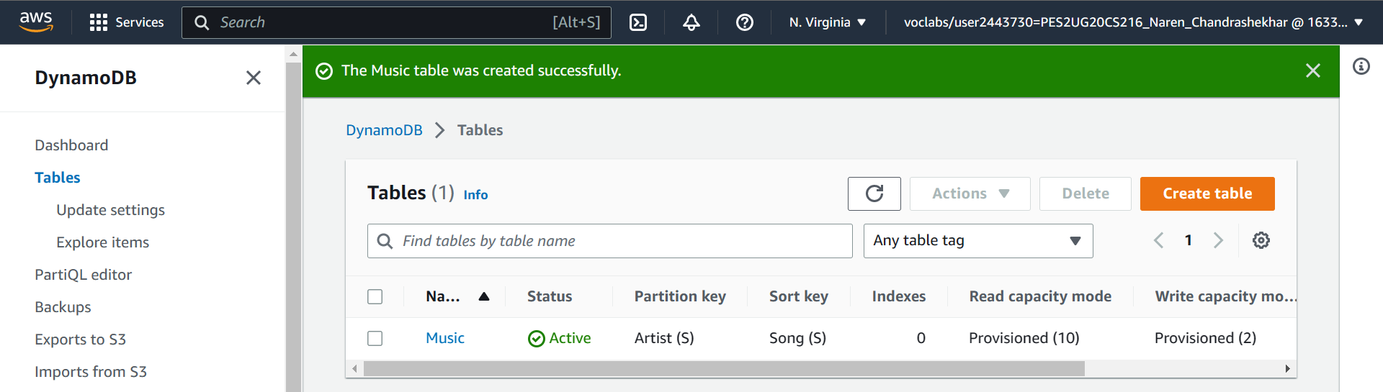

* Screenshot 2a: Show the inserted entries in table **(Make sure the Items returned table is expanded such that all fields are shown and the name of the Table is also visible to the left)** (2 marks)

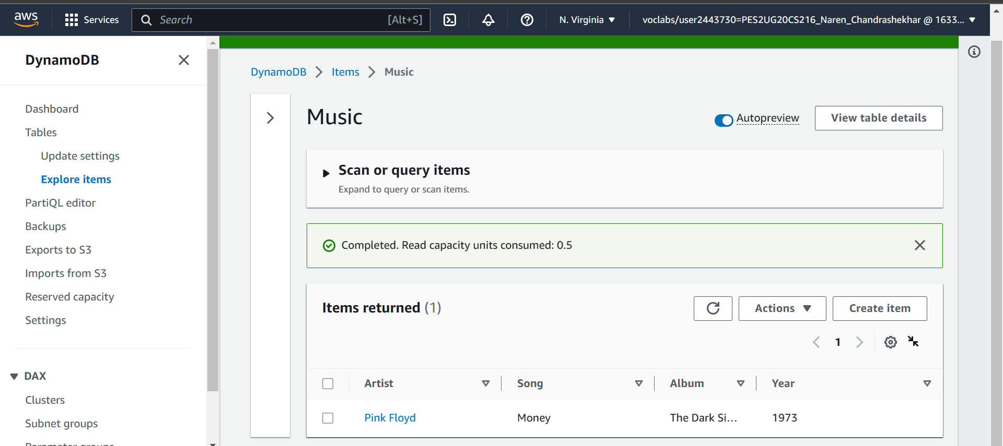

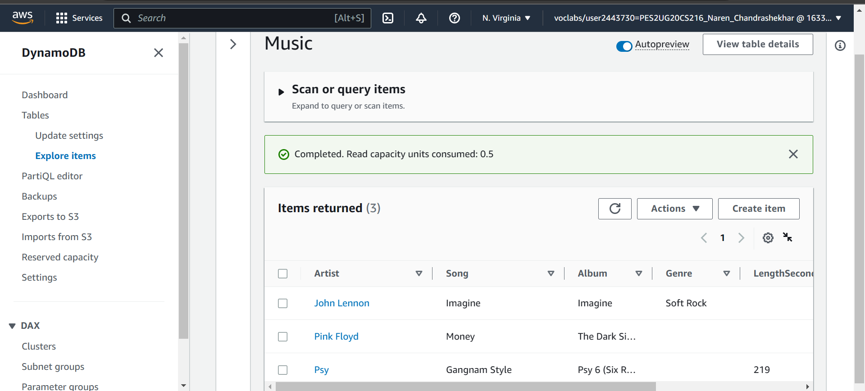

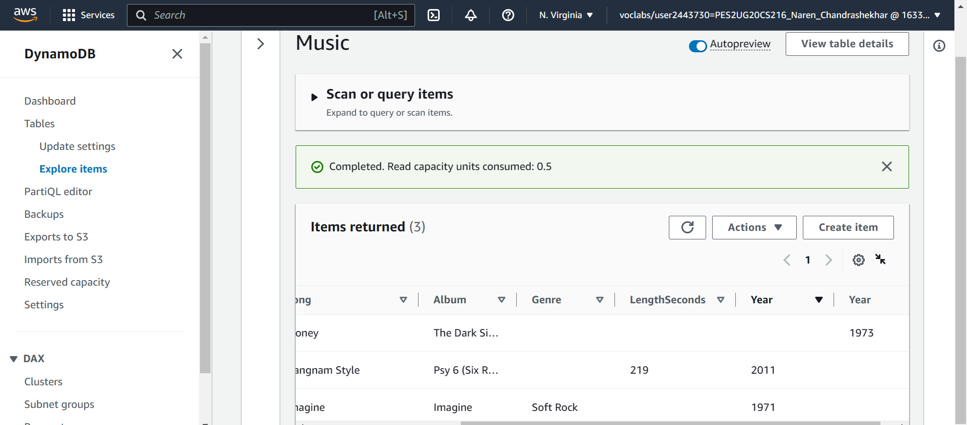

* Screenshot 3a: Show the entries post update **(Make sure the Items returned table is expanded such that all fields are shown and the name of the Table is also visible to the left)** (2 marks)

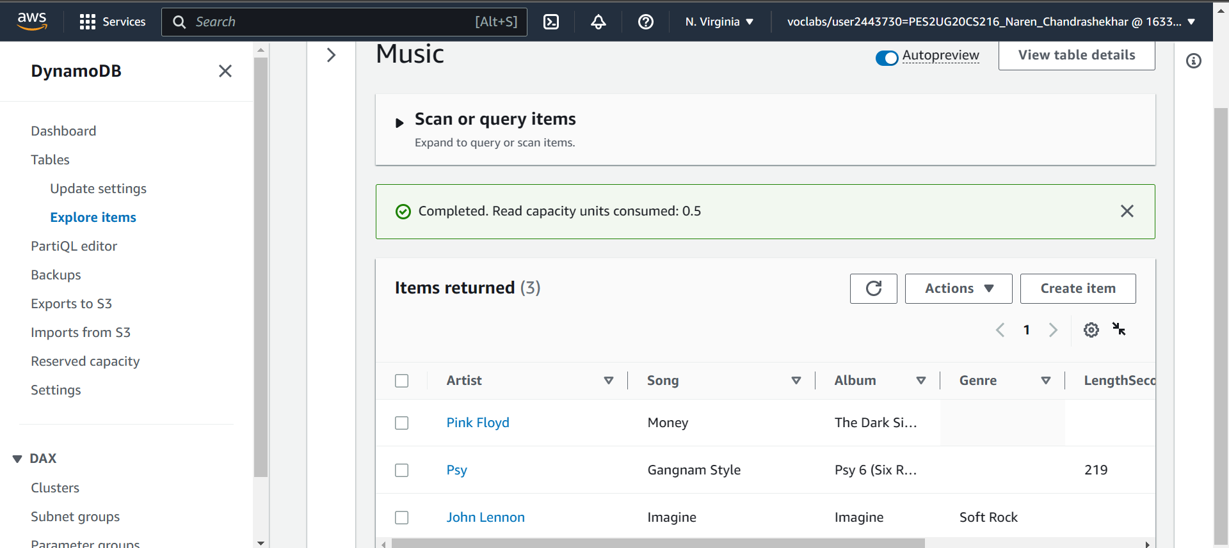

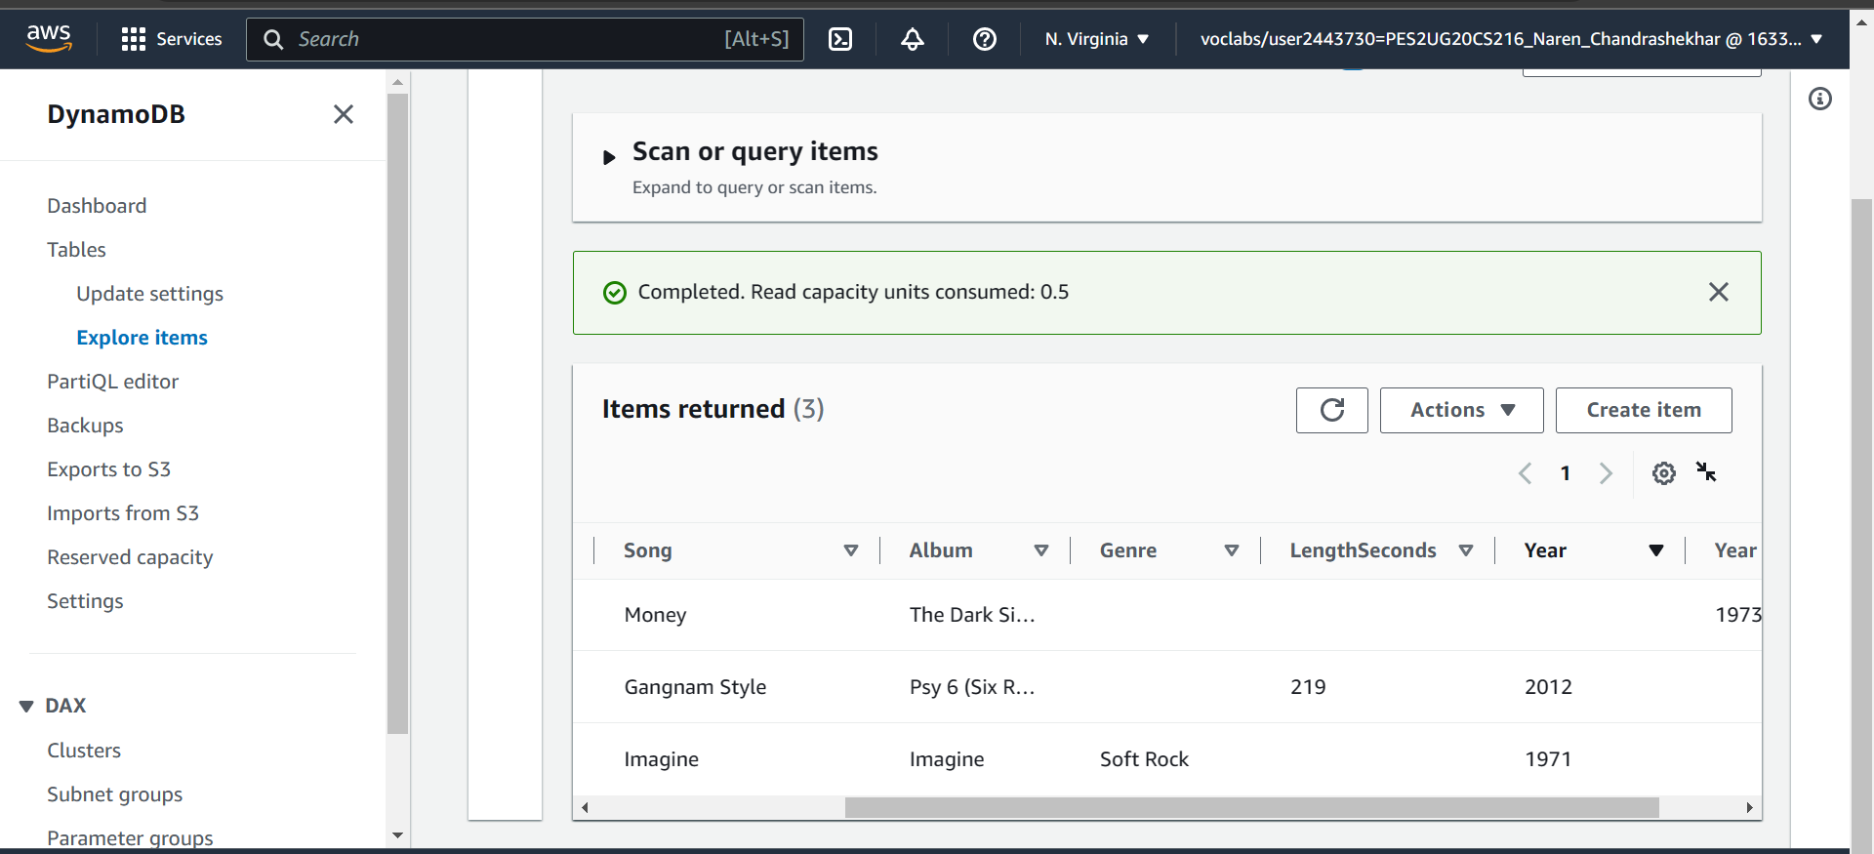

* Screenshot 4a: Result of the query Artist (Partition key): Psy, Song (Sort key): Equal to Gangnam Style **(Make sure both the query parameters filled are visible along with the result of the query)** (2 marks)
* 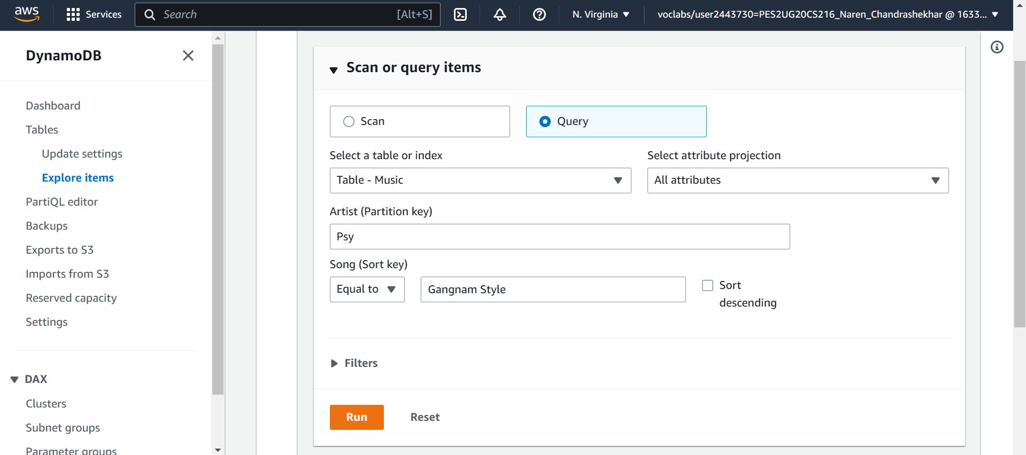

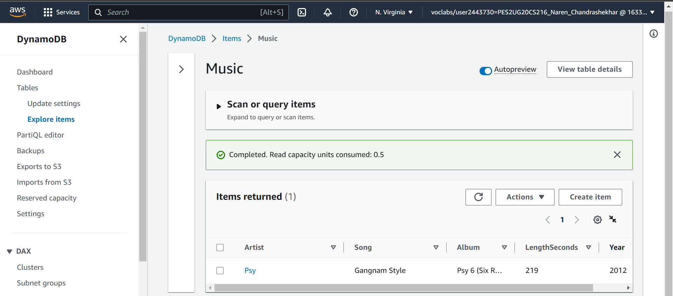

* Screenshot 4b: Result of Scan filter **(Make sure the ‘Scan’ radio button selection, Attribute name and the result are present in the screenshot)** (2 marks)

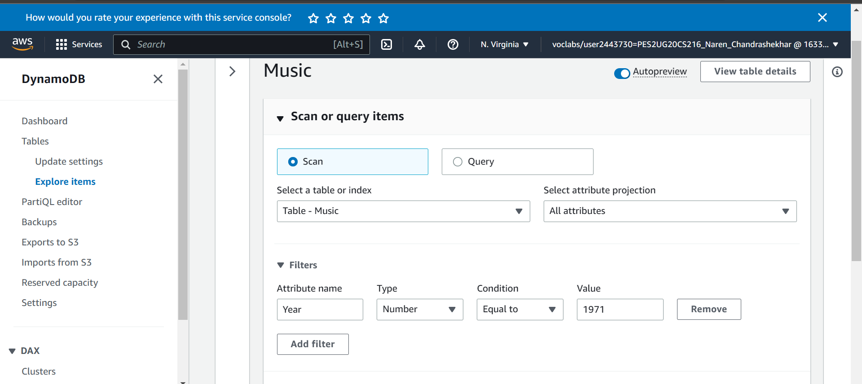

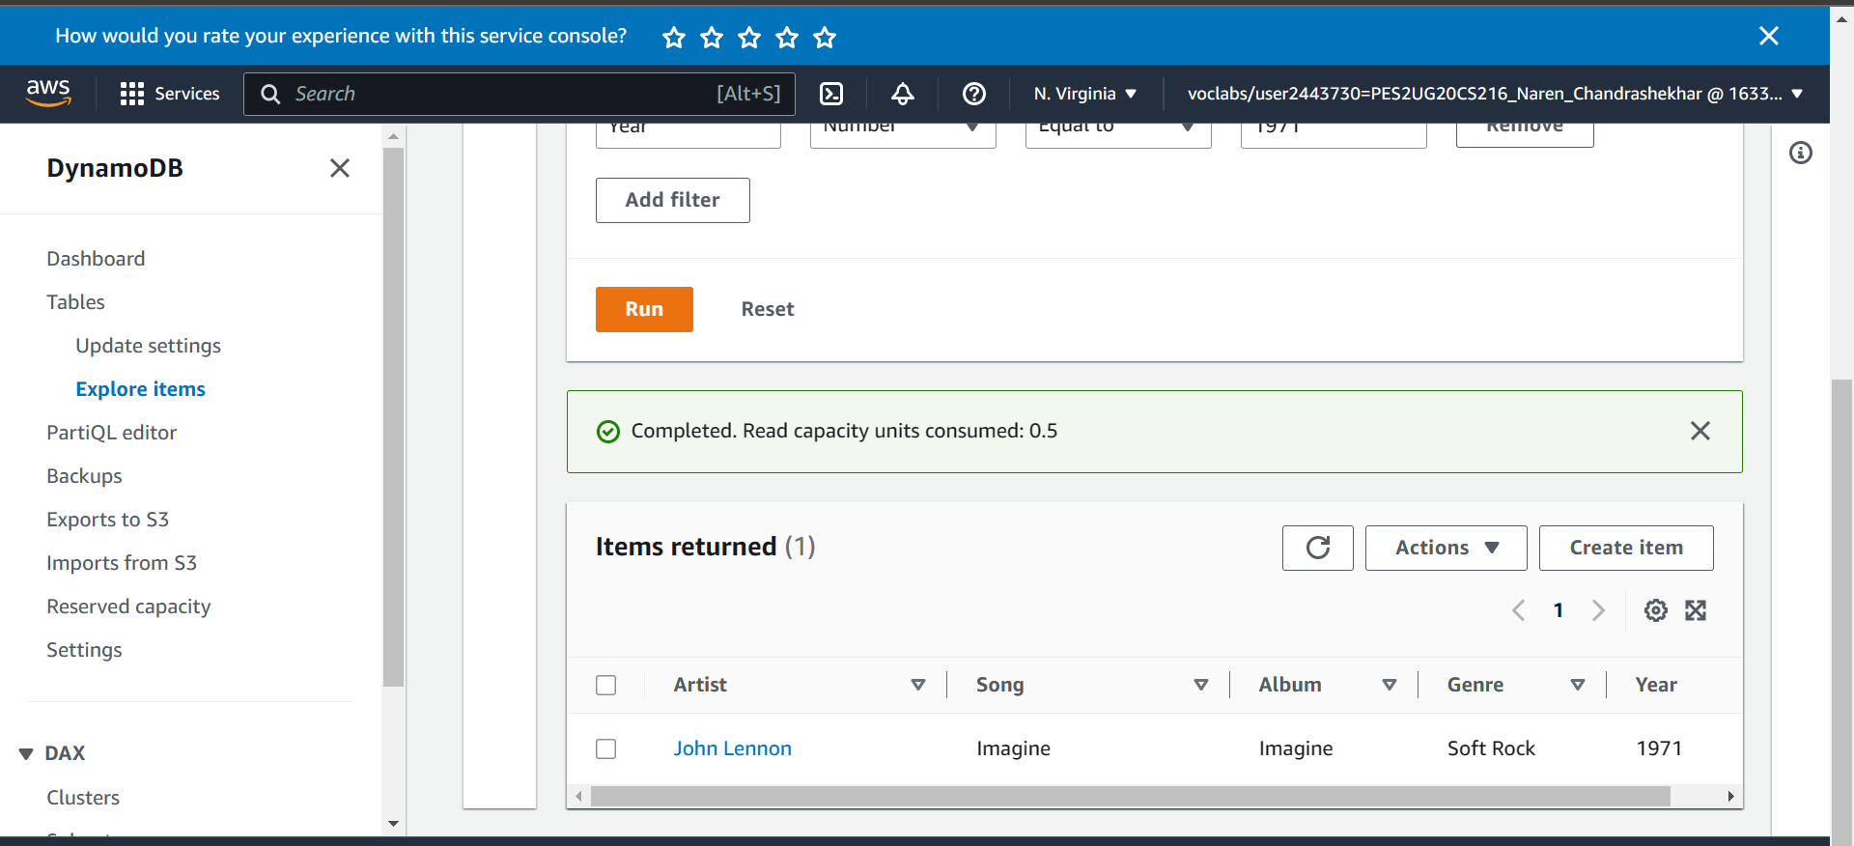

* Screenshot 5a: Data after deletion of an item from the table (1 mark)

